List of Practical

|  |  |  |  |
| --- | --- | --- | --- |
| **Exp. No.** | **Experiment Title** | **Date** | **Signature** |
| **1** | Study of Various Virtualization Software such as VMware, QEMU, KVM, XEN Hypervisor and Oracle Virtual Box. | 11-01-24 |  |
| **2** | Exploring Oracle VM VirtualBox to create the virtual Machines | 18-01-24 |  |
| **3** | To Install and configure VMware Workstation Pro or Oracle Virtual Box for creating Virtual Machines, cloning, and deleting VMs. | 01-02-24 |  |
| **4** | To Explore Docker Container | 15-02-24 |  |
| **5** | Create two dockers with front-end and back-end applications and connect these containers. | 14-03-24 |  |
| **6** | Create a customized docker image and perform the given instructions | 28-03-44 |  |
| **7** | Create three containers and access these containers from each other by using IP address and container name. | 04-04-24 |  |
| **8** | Re-Do the problem of Lab 5 using docker compose. Also do assign a static IP address to WordPress container using subnetting. | 25-04-24 |  |

**PRACTICAL 1**

**Aim:** Study of Various Virtualization Software such as VMware, QEMU, KVM, XEN Hypervisor and Oracle Virtual Box.



1. **Compare their Virtualization type and methodologies.**

**Virtualization Types**

1. **Full Virtualization**

* This technique emulates the complete hardware environment
* Allows any guest OS to run on the VM
* VMware and VirtualBox utilize Full Virtualization

1. **Para Virtualization**

* This technique modifies the guest OS to interact with the Hypervisor
* Offers better performance than full virtualization but requires compatibility between guest OS and Hypervisor
* Xen and KVM utilize Para Virtualization

1. **Hardware assisted Virtualization**

* This technique leverages special features built into modern processors to improve virtualization performance and security
* Features like translating guest OS memory addresses to physical memory addresses.
* VMware ESXi and Xen utilize hardware assisted virtualization.

**Methodologies**

1. **VMware**

* Uses a technique called hardware-assisted virtualization where it leverages features provided by modern CPUs (Intel VT-x or AMD-V) to improve the efficiency of virtualization

1. **QEMU**

* QEMU utilizes dynamic binary translation to emulate the guest CPU instructions
* Dynamic binary translation is particularly useful in scenarios where direct execution of guest instructions on the host is not feasible due to architectural differences. This process occurs dynamically at runtime, translating the binary code of guest instructions to equivalent instructions that can be executed on the host system

1. **KVM**

* KVM leverages hardware virtualization extensions (Intel VT-x or AMD-V) to provide a direct interface to the host's CPU for virtualization. It works as a kernel module and relies on the Linux kernel's scheduler and memory management.

1. **XEN Hypervisor**

* Xen uses a microkernel design where the hypervisor runs as a separate, lightweight kernel (the "Xen hypervisor") above the hardware. It allows multiple operating systems to run concurrently in isolated domains (known as Xen domains or VMs). Each domain has its own kernel, and the hypervisor manages their access to hardware resources.

1. **Oracle VirtualBox**

* VirtualBox runs as a user-space application on the host operating system. It uses a combination of dynamic binary translation and various device drivers to emulate hardware and provide a virtualized environment for guest operating systems

1. **Identify architectural difference.**

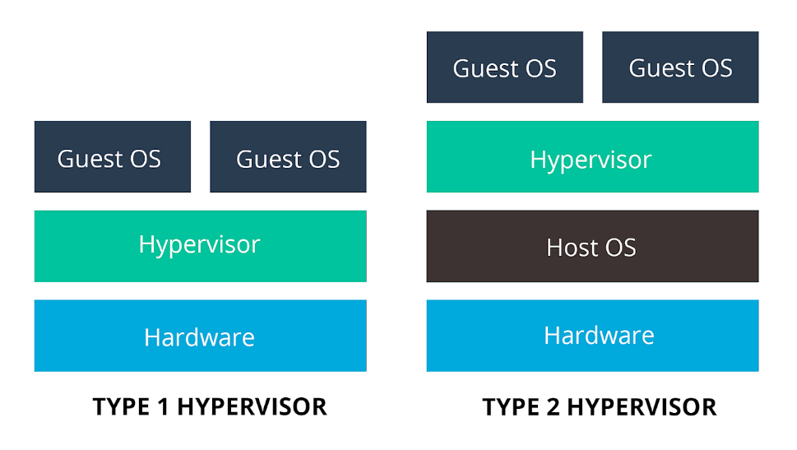

|  |  |  |  |  |  |
| --- | --- | --- | --- | --- | --- |
| **Software** | **VMware** | **QEMU** | **KVM** | **Xen** | **Oracle VirtualBox** |
| **Type** | Type 1 (bare-metal) and Type 2 (hosted) | Type 1 (bare-metal) and Type 2 (hosted) | Type 2 (hosted) | Type 1 (bare-metal) and Type 2 (hosted) | Type 2 (hosted) |
| **Focus** | Enterprise virtualization, desktop virtualization, cloud computing | Machine emulation, basic virtualization | Open-source virtualization for Linux | Open-source cloud infrastructure, server virtualization | Free personal virtualization, educational tool |
| **Pros** | Robust features, high performance, advanced security | Open-source, highly flexible, good for emulation | Free, open-source, efficient for Linux | Open-source, widely used in cloud, robust features | Free, cross-platform, easy to use |
| **Cons** | Can be expensive, complex to manage | Limited features in hosted version, not ideal for high-performance workloads | Requires Linux kernel, not as user-friendly as some options | Less mature than some Type 1 hypervisors, may not be suitable for all workloads | Limited features compared to some enterprise solutions |

1. **List out various advantages, disadvantages and applications.**
2. **VM Ware**

**Advantages:**

* Management Tools: Comprehensive management tools like vSphere, advanced features such as vMotion for live migration.
* Compatibility: Wide compatibility with various operating systems and Widely used in enterprise environments

**Disadvantages:**

* Cost Concerns: VMware can be expensive due to licensing fees, which might be challenging for smaller businesses.
* Limited Flexibility: VMware's proprietary nature can limit customization options compared to open-source alternatives.

**Applications:**

* Server Virtualization: VMware is extensively used for server virtualization, allowing multiple virtual machines (VMs) to run on a single physical server.
* Desktop Virtualization: VMware provides solutions for desktop virtualization, enabling organizations to centralize desktop management and delivery.
* Cloud Computing: VMware's virtualization technology is used in building and managing cloud infrastructures.

1. **QEMU**

**Advantages:**

* Emulation: Can emulate various hardware devices beyond virtualization, ideal for testing and development.
* Lightweight: Less resource-intensive than some other options, suitable for lower-powered environments.

**Disadvantages:**

* Speed Issues: QEMU may not be as fast as other options, especially in situations where a lot of resources are needed.
* Not User-Friendly: Setting up QEMU can be complex, especially for those who prefer graphical interfaces over command lines.

**Applications:**

* Emulation: QEMU is often used for hardware emulation, allowing software to run on platforms for which it was not originally designed.
* Cross-Platform Development: Developers use QEMU to test software on different architectures without the need for physical hardware.
* System Recovery: QEMU can be employed for system recovery and backup purposes.

1. **KVM**

**Advantages:**

* Built-in: Included in the Linux kernel, providing seamless integration and native performance.
* Open-source: Free and community-driven, making it accessible and customizable.

**Disadvantages:**

* Linux Focus: KVM works best with Linux, which may be a drawback for environments where Linux isn't the main operating system.
* Hard to Set Up: Getting KVM up and running can be complicated, especially for users unfamiliar with Linux.

**Applications:**

* + Performance: KVM can provide high-performance virtualization by leveraging hardware support.
  + Cloud Computing: KVM is widely used in cloud computing environments, providing a robust and efficient virtualization solution.
  + Flexibility: Supports a wide range of guest operating systems.

1. **XEN Hypervisor**

**Advantages:**

* Type-1  hypervisor: Offers **high performance** and isolation for critical workloads.
* Security focus: Designed with security in mind, incorporating features like **memory paging** and security domains.

**Disadvantages:**

* Limited Graphics Support: Xen traditionally has **limited support** for **graphics-intensive applications**.
* Lack of USB Passthrough Support: Xen has faced **challenges** with **USB passthrough** support.

**Applications:**

* Server Consolidation: Xen is used for server consolidation, allowing **multiple virtual servers** to run on a single physical server.
* Cloud Hosting: Xen is utilized in many **cloud hosting platforms** to provide virtualized instances to users.
* Isolation: Xen's architecture provides **strong isolation** between virtual machines, enhancing security.

1. **Oracle VirtualBox**

**Advantages:**

* Free and easy to use: Ideal for individual users and smaller deployments.
* User-friendly interface: Simple and intuitive for beginners to set up and manage VMs.

**Disadvantages:**

* Performance Drawbacks: VirtualBox might not handle high-demand situations as well as some other options.
* Lacking Advanced Features: VirtualBox may lack some advanced features found in solutions like VMware, which could be a drawback for enterprise users.

**Applications:**

* Desktop Virtualization: VirtualBox is commonly used for desktop virtualization, enabling users to run multiple operating systems on a single physical machine.
* Development and Testing: VirtualBox is popular for development and testing environments, allowing developers to create and test applications on various operating systems.
* Education and Training: VirtualBox is used in educational settings to create virtual labs and facilitate hands-on training in different operating systems.

**PRACTICAL 2**

**Aim:** Exploring Oracle VM VirtualBox to create the virtual Machines



1. **Create Two or more Virtual Machine and assign resources.**

* Click on New button on Home Page. Choose file path of OS.

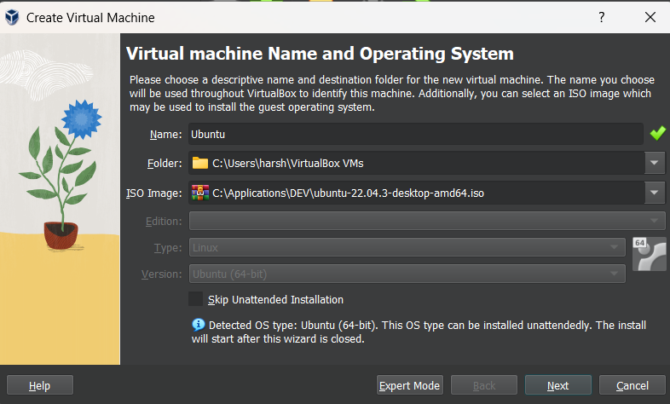

* Give User details

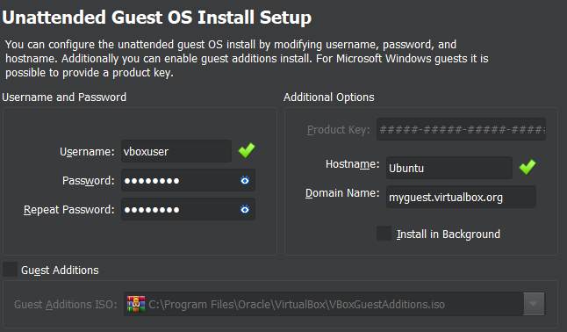

* Allocate Memory and Processors

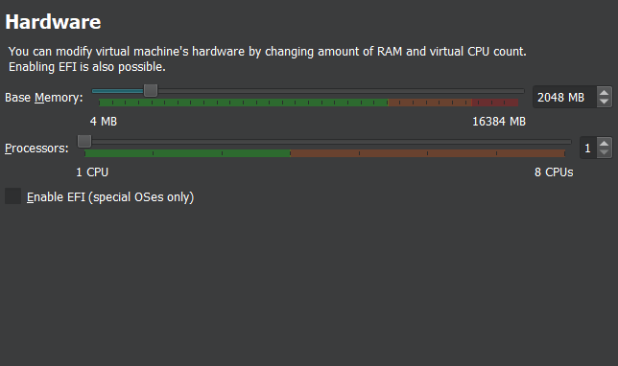

* Allocate Disk Space

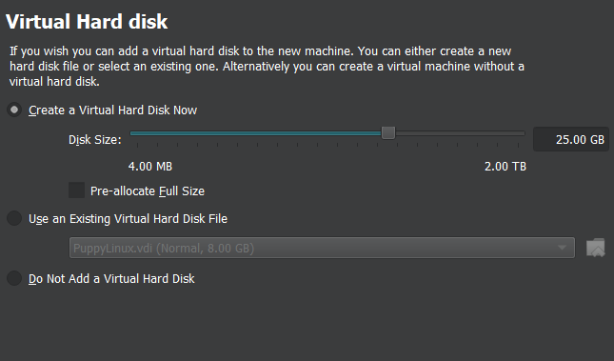

* Check Summary and click Finish. Do the same for other VM.

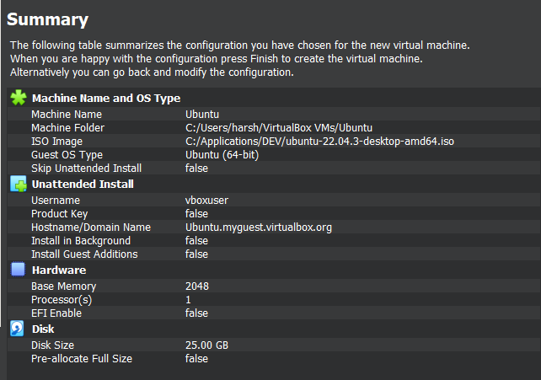 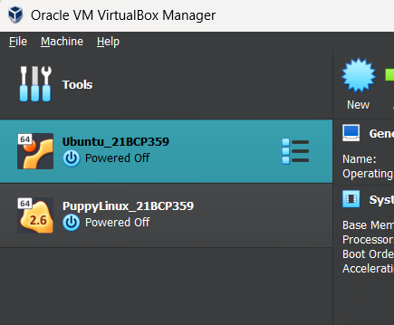

1. **Install two or more Guest Operating Systems on all the VMs**

* Click on New button on Home Page. Choose file path of OS.



* Give User details



* Allocate Memory and Processors



* Allocate Disk Space



* Check Summary and click Finish. Do the same for other VM.

 

1. **Run simple applications or programs on all the VMs.**
2. **Run a simple Python script printing even numbers in VM-1 at 5 sec intervals.**

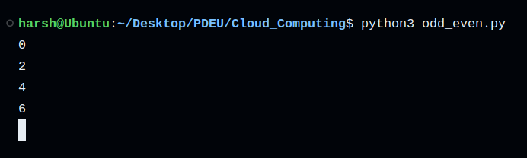

1. **Run a simple Python script printing odd numbers in VM-2 at 5 sec intervals.**

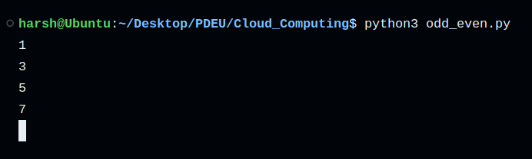

1. **View system configurations of each VM. Check whether it is same different from what you have created.**

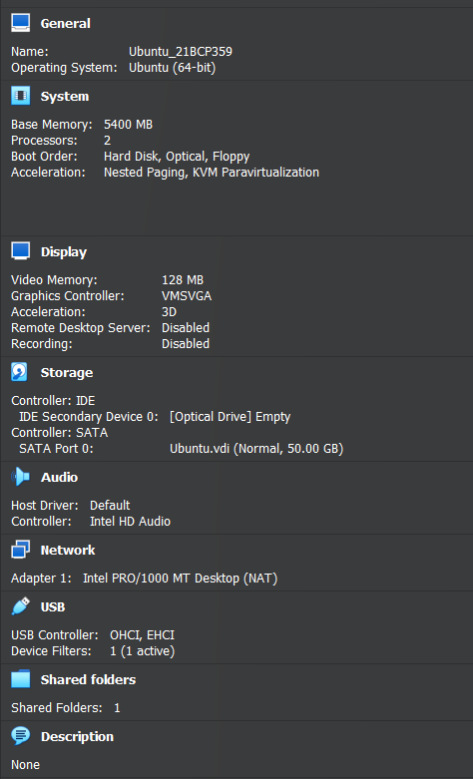 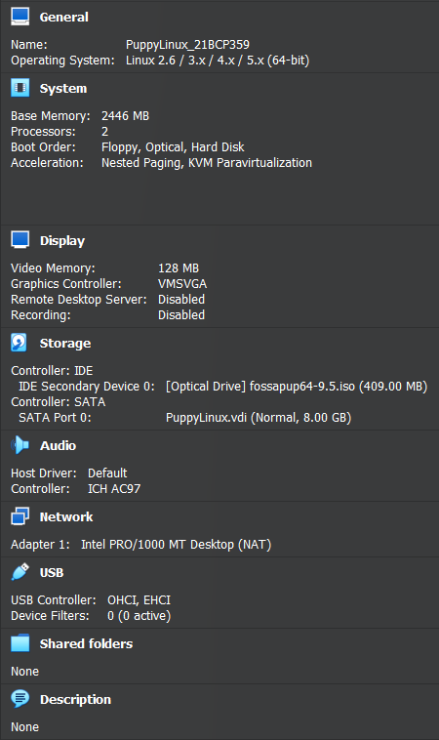

**PRACTICAL 3**

**Aim:** To Install and configure VMware Workstation Pro or Oracle Virtual Box for creating Virtual Machines, cloning, and deleting VMs.



1. **Cloning of Virtual Machines:**
2. **Linked Cloning**

* Right Click on VM and select clone

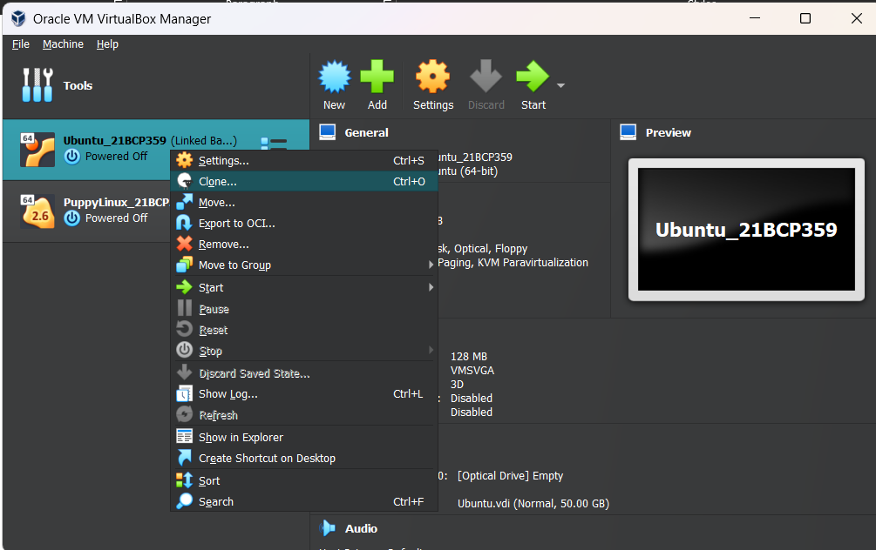

* Give necessary details

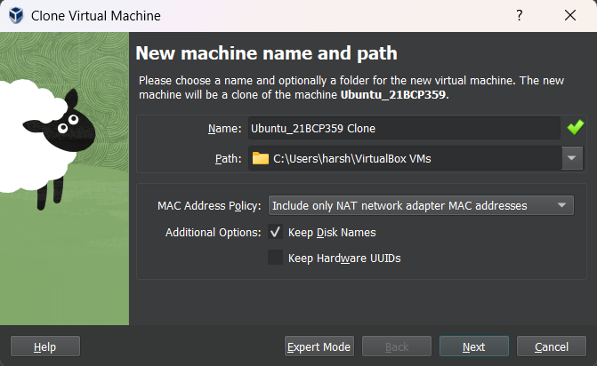

* Select Linked Clone

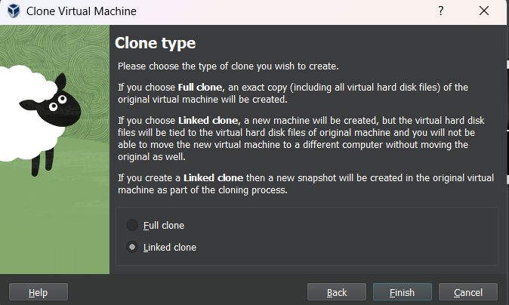

* The Linked Clone is Ready

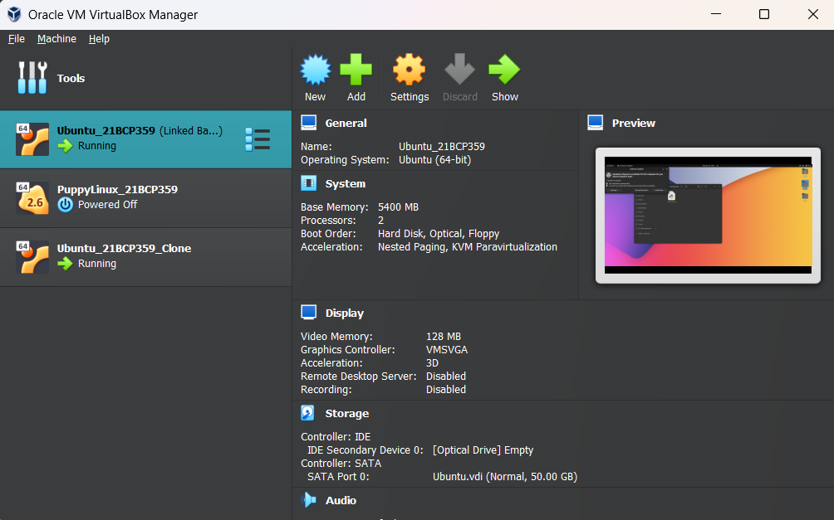

1. Full Cloning

* Right Click on VM and select Clone



* Give Necessary details



* Select Full Clone

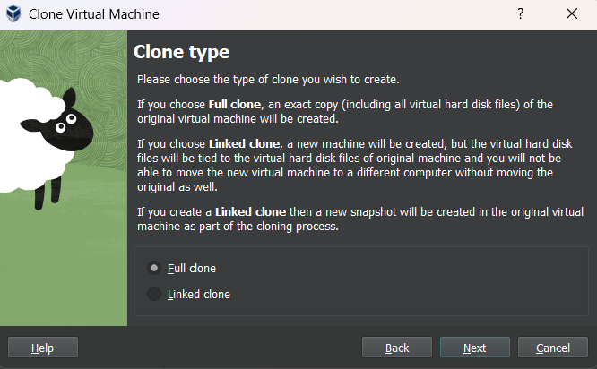

* Snapshots: Select Current Machine State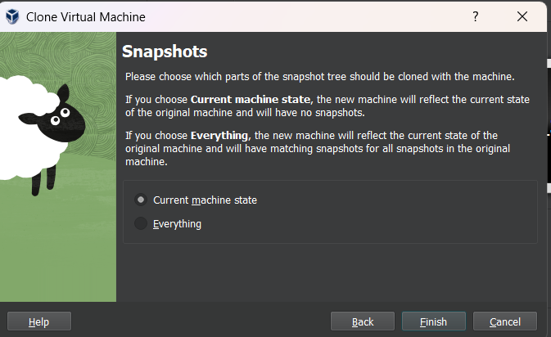

1. **Add a USB Controller to Virtual Machine**

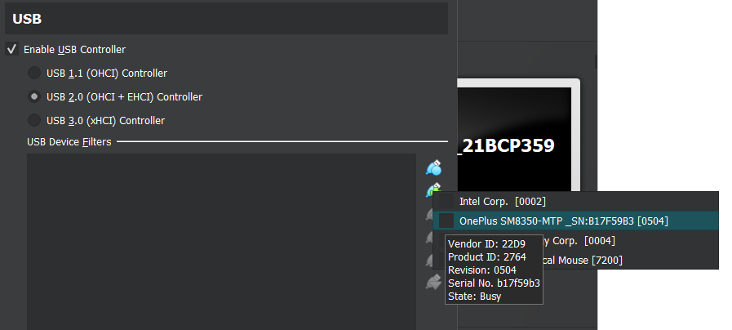

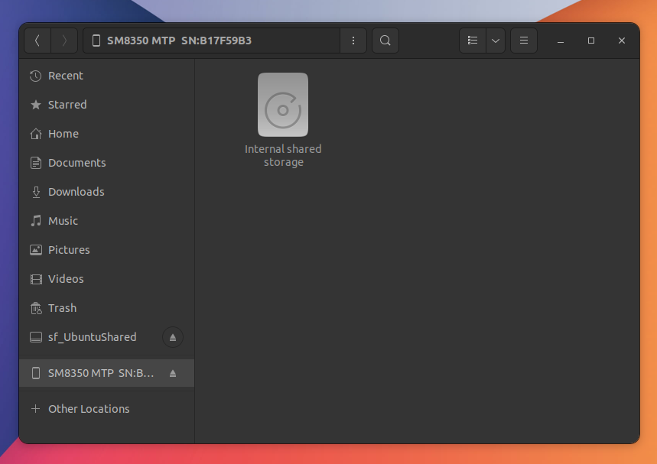

1. **Closing Virtual Machines & Exiting VMM**
   1. Hard Power Off

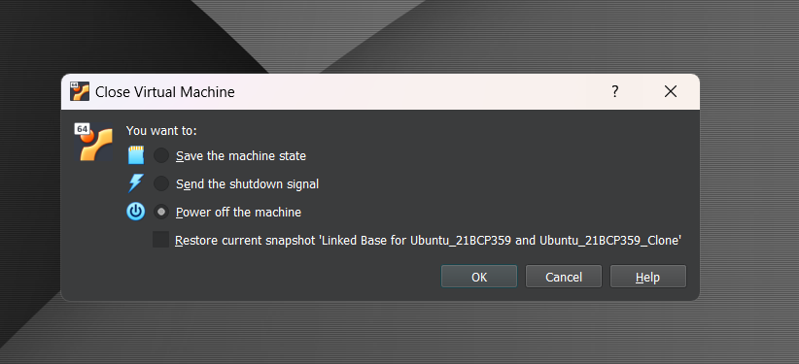

* 1. Soft Power Off

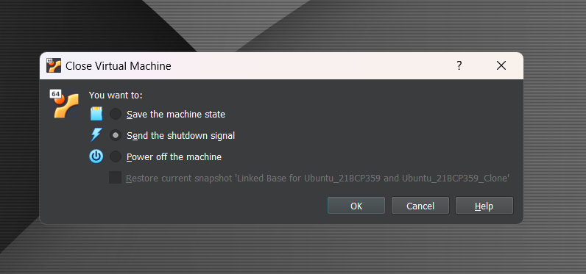

* 1. Configure Virtual Machine to Run in the Background



* In Start menu of VM click Headless Start

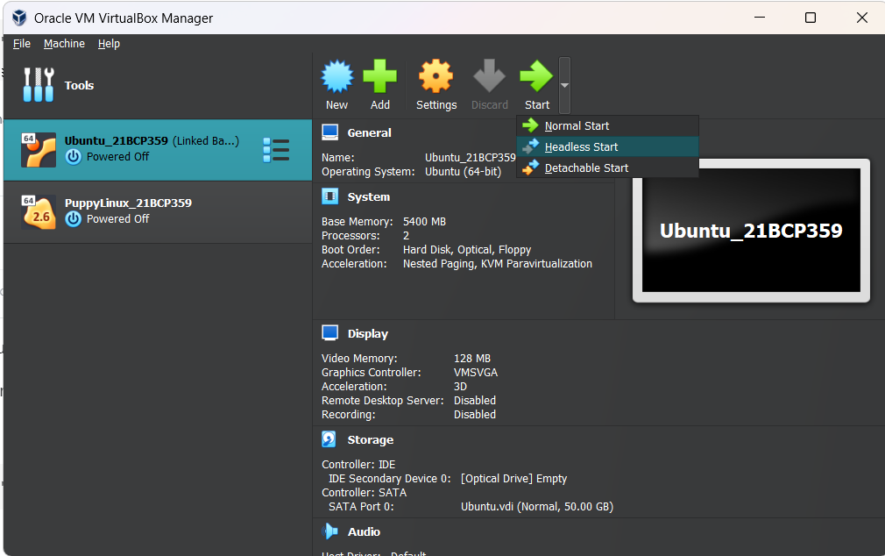

* 1. Pause and Un-pause a Virtual Machine



Right click on VM and click Pause to Pause

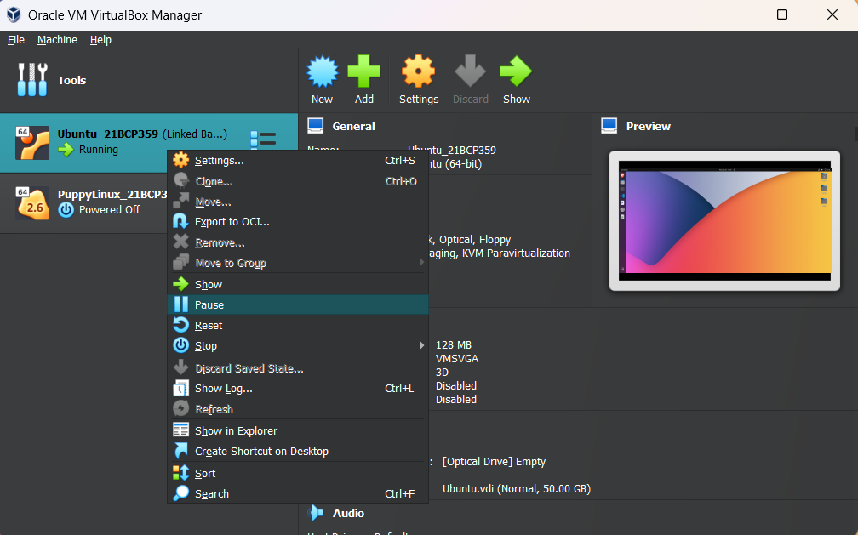

Again click Pause to Resume

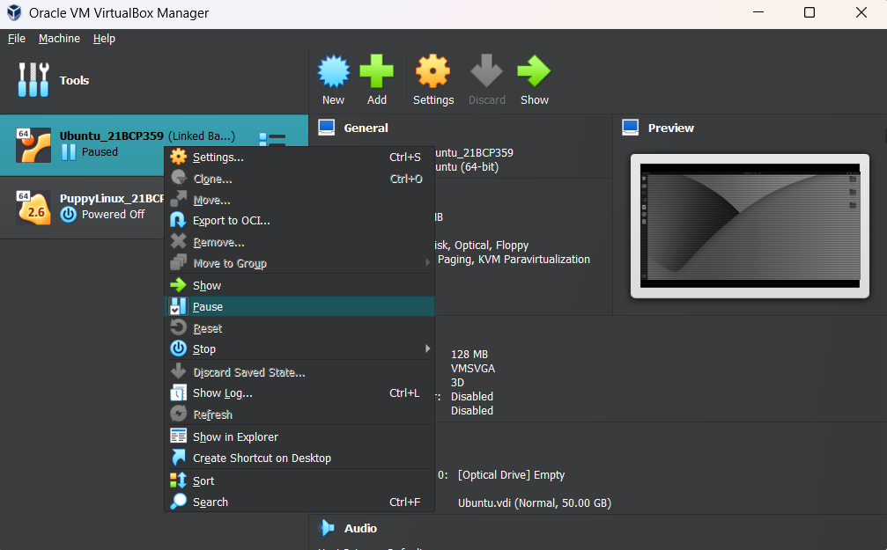

* 1. Pause all Virtual Machine without interacting Virtual Box

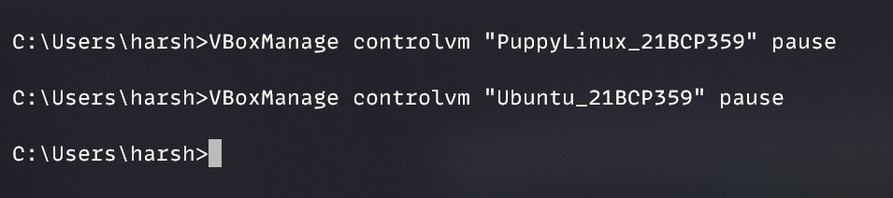

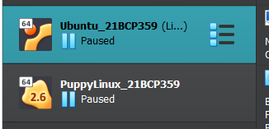

* 1. **Suspend and Resume Virtual Machines**

In power menu of Guest OS click Suspend

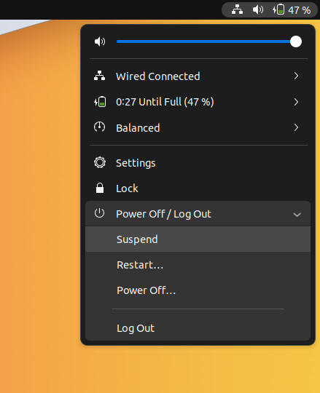

1. **Delete a Virtual Machine from the disk**

Right click on VM and select Delete. Then click Delete all files

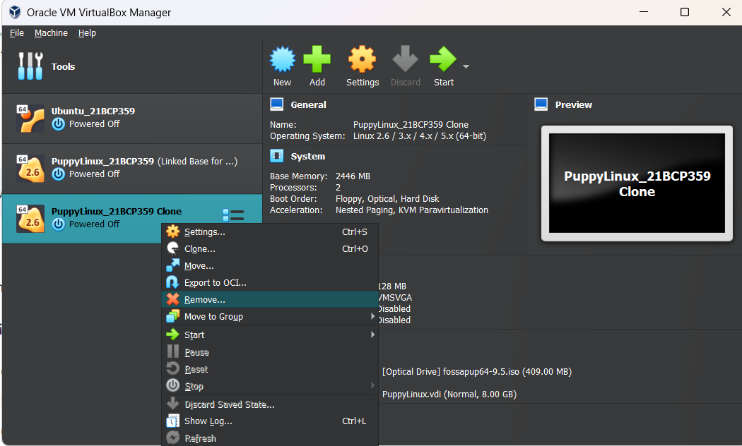 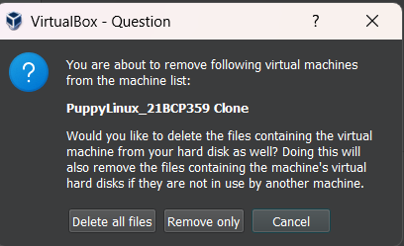

1. **To take snapshot of Virtual Machines**

Click on Tools icon on VM and select Snapshots. Give a name and click OK

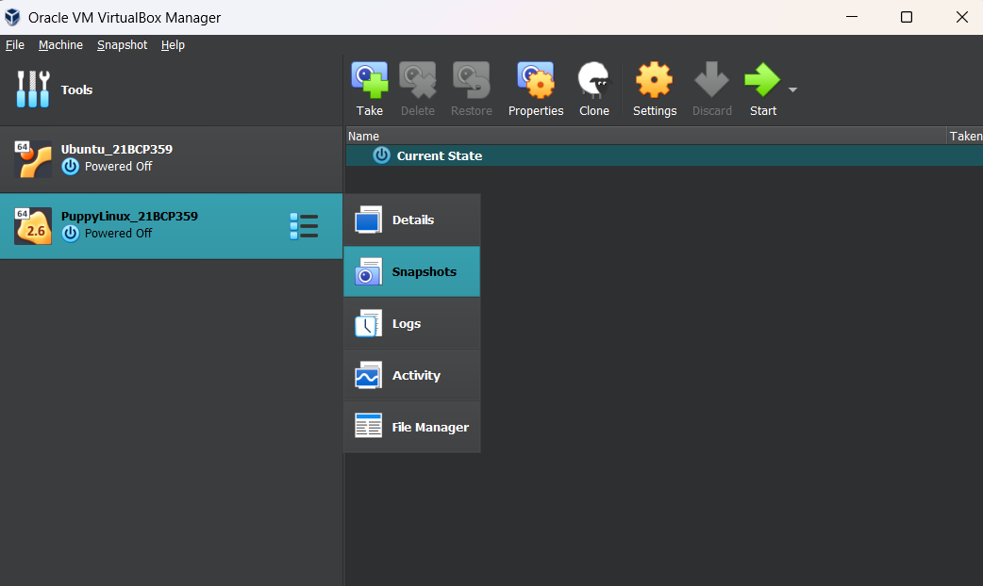 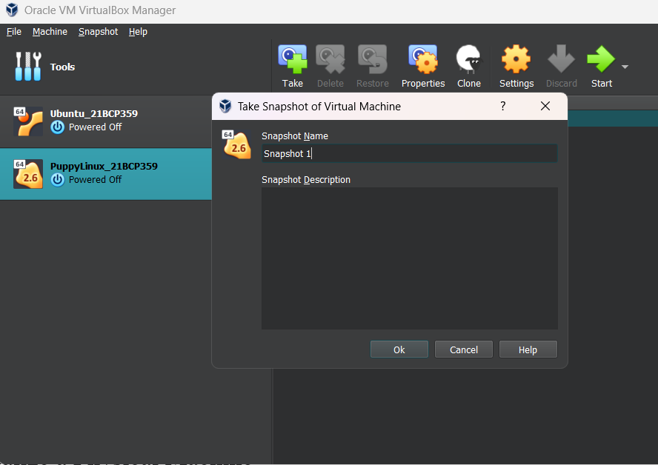

**PRACTICAL 4**

**Aim:** To Explore Docker Container

1. **Install Docker in your environment**

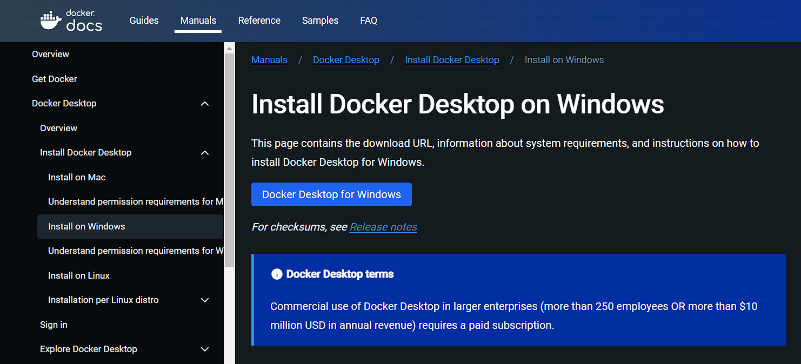

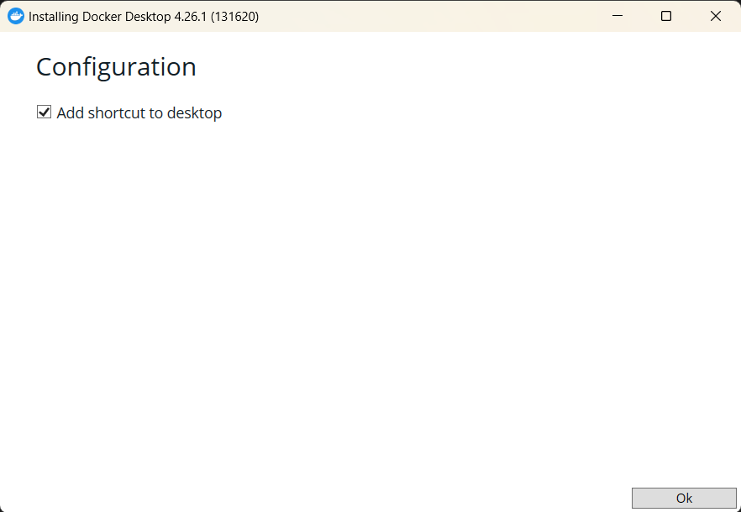

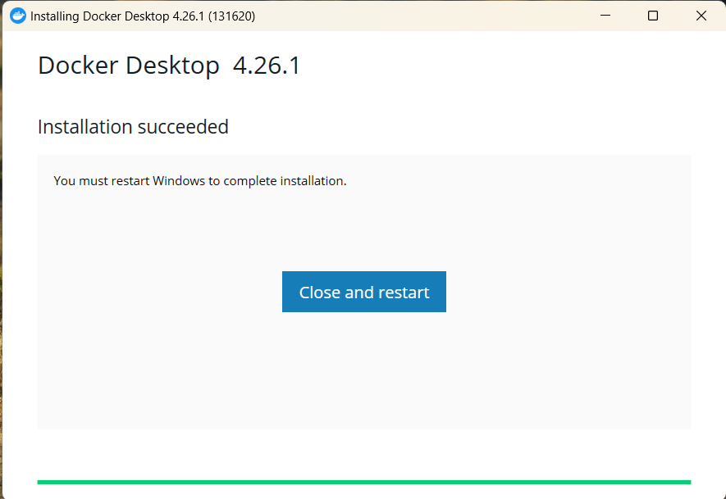

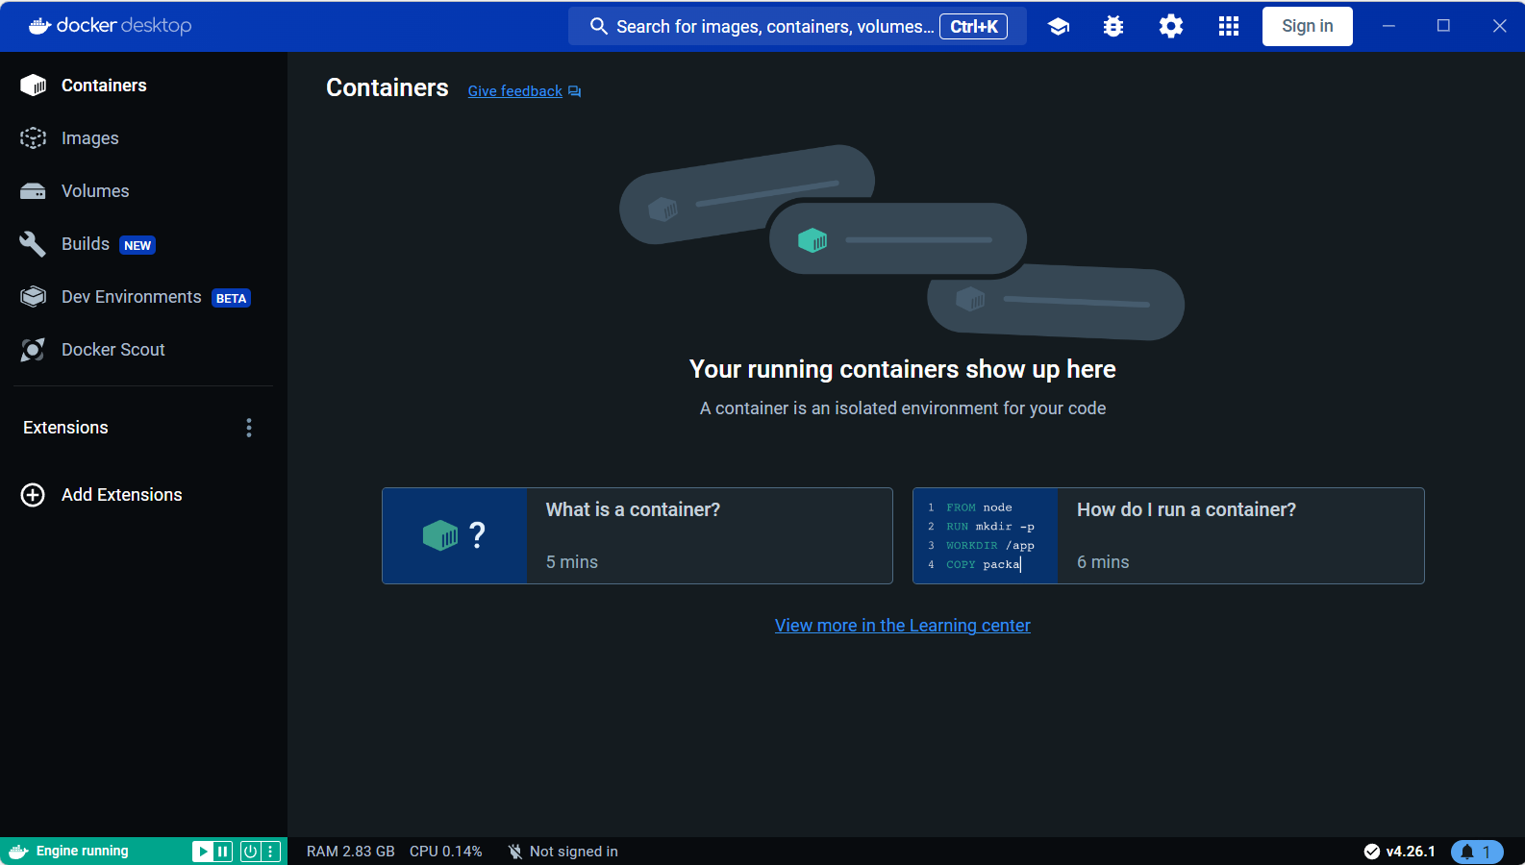

1. **Verify your Docker by looking up the version**

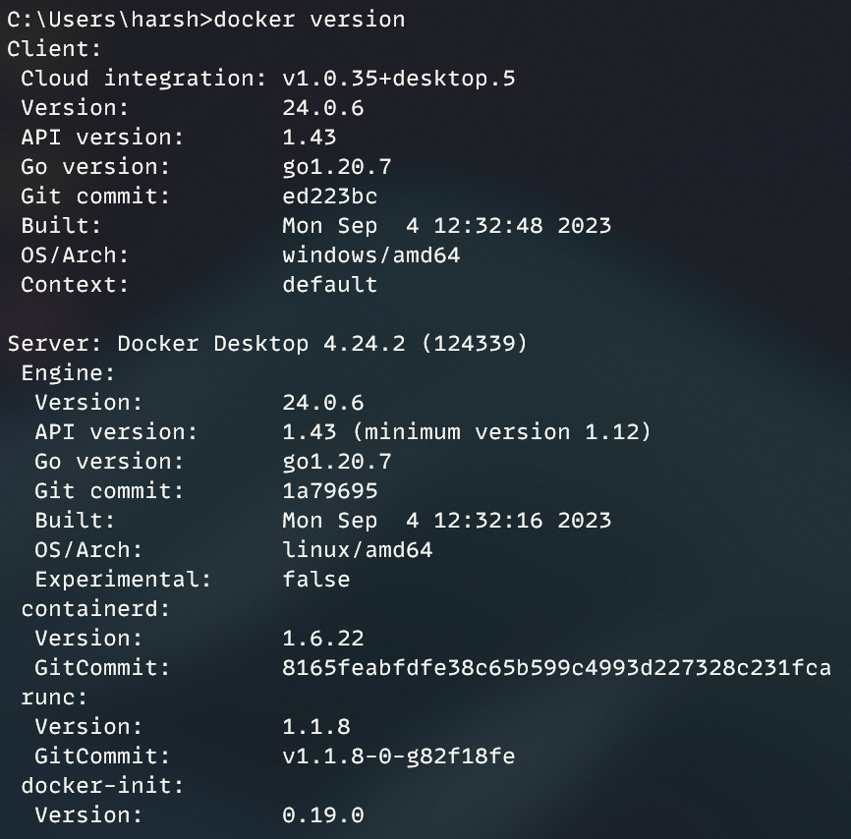

1. **Run a hello-world container**

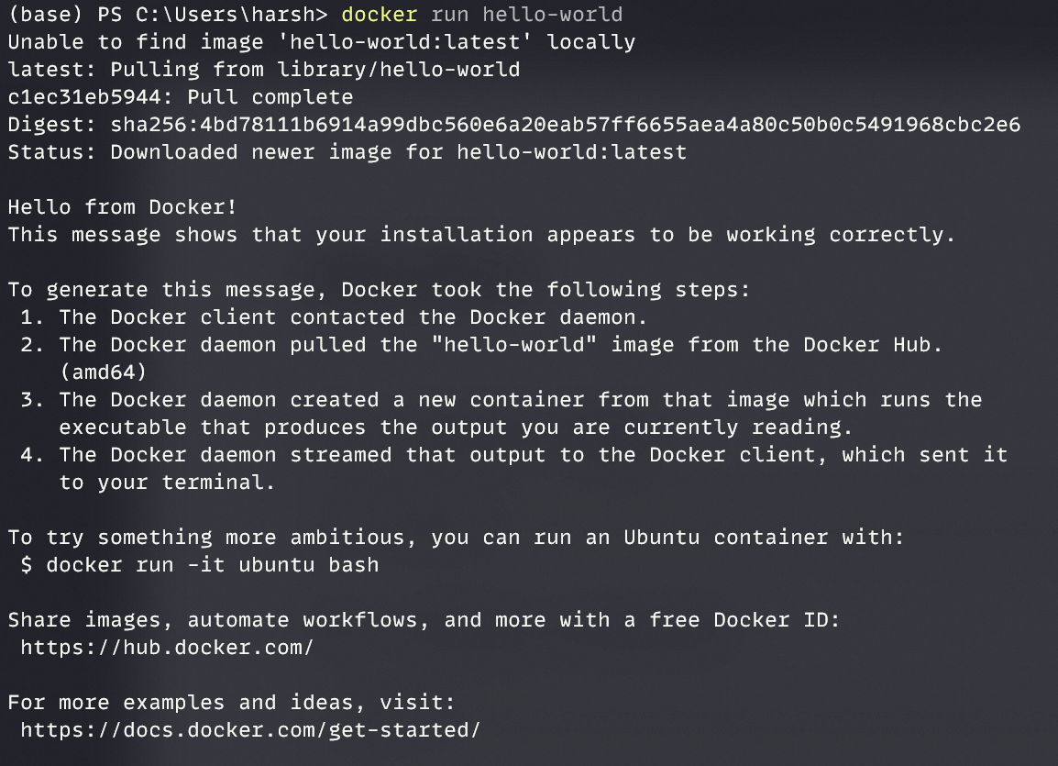

1. **Verify the hello-world image**

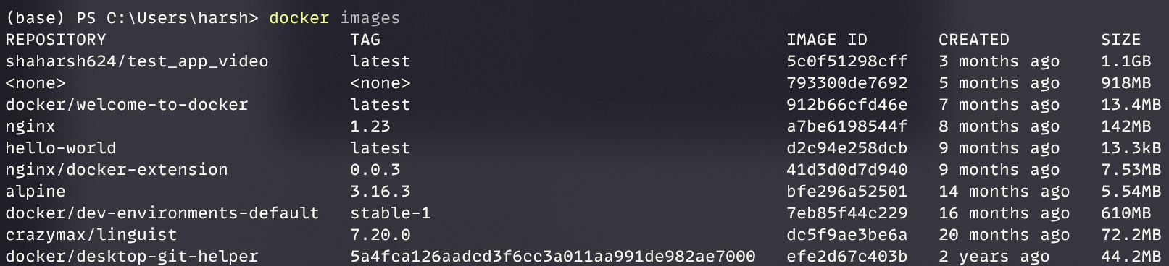

1. **Get the sample application**

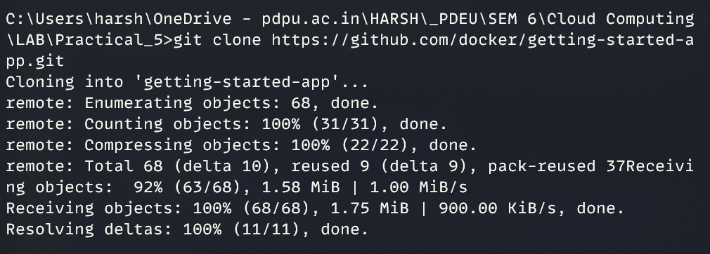

1. **Run the application on the Docker**
   1. **Build the Docker Image**

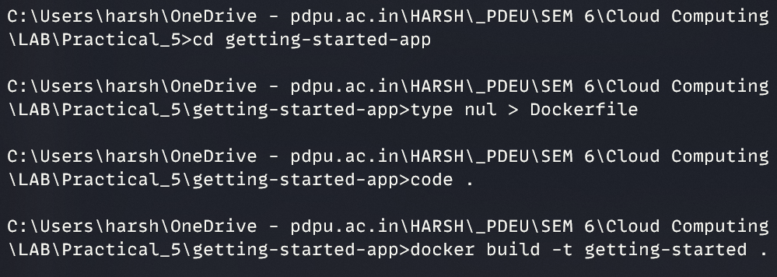

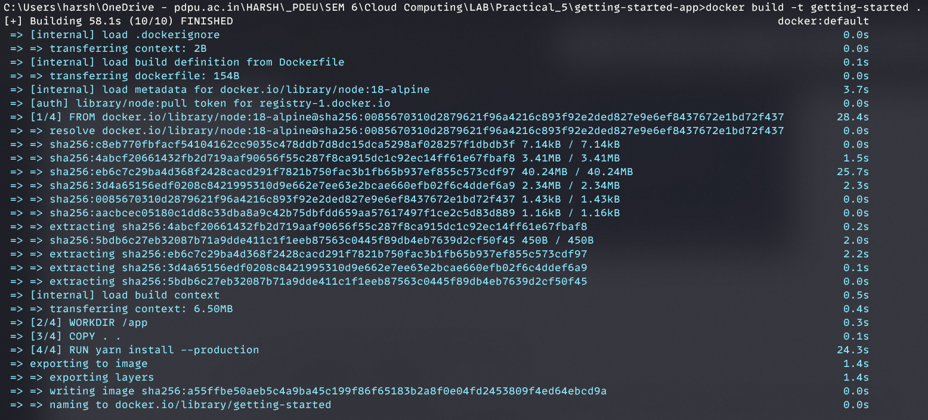

* 1. **Verify the newly build image**



1. **Run the Docker container**
   1. **Run the container in the detached mode. Name the container “Test Sample”.**

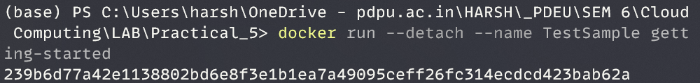

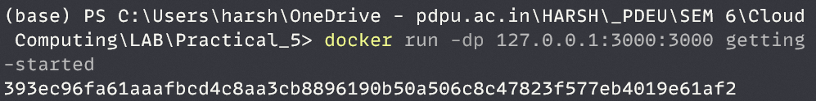

* 1. **List all the running containers.**



* 1. **Inspect the running containers**

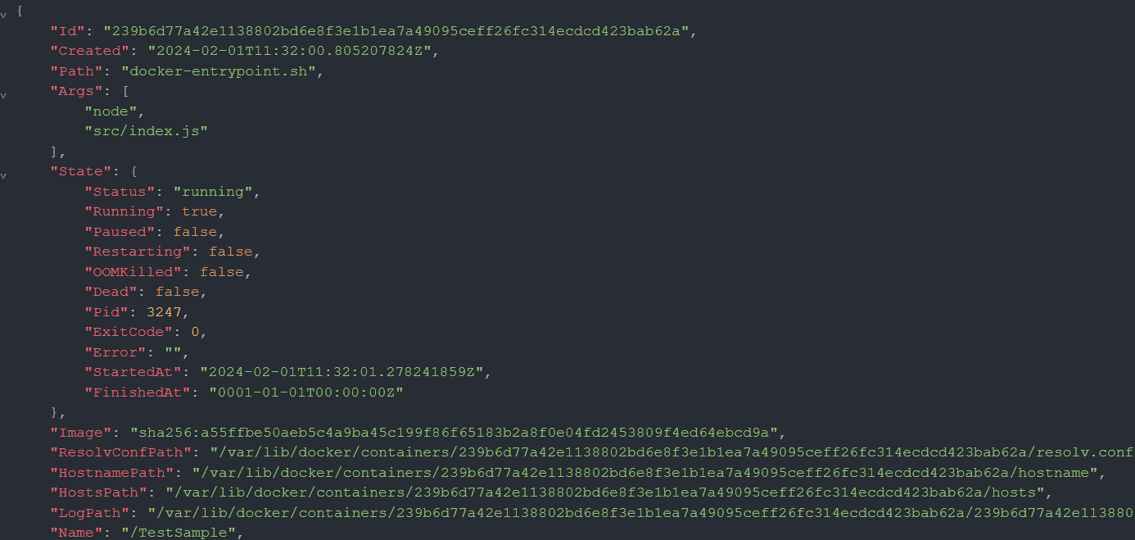

* 1. Get the logs of “Test Sample” containers

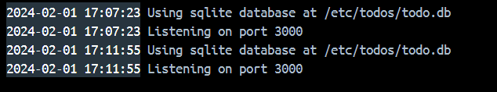

1. **Access the application**

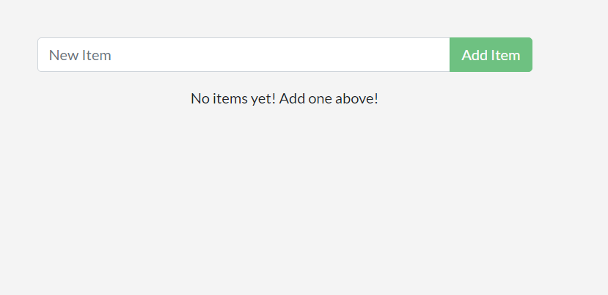

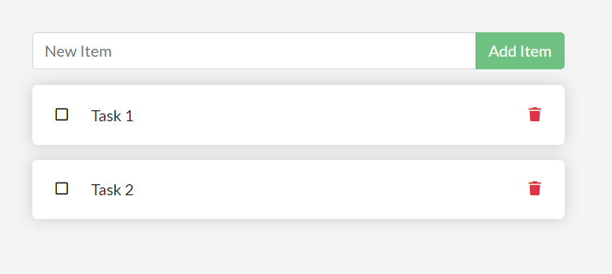

1. **Pushing and pulling an image to and from repository**

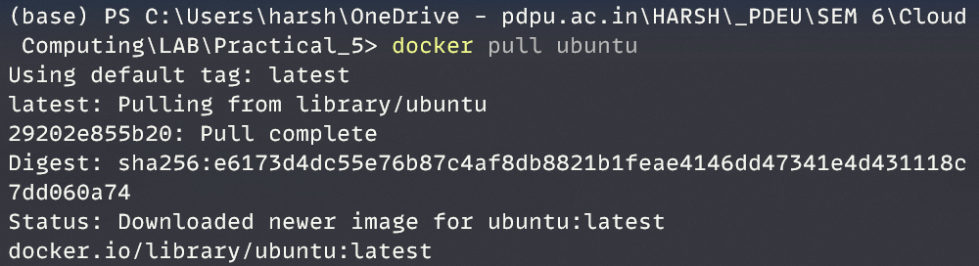



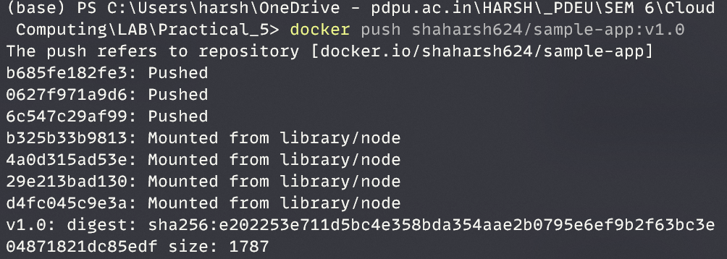

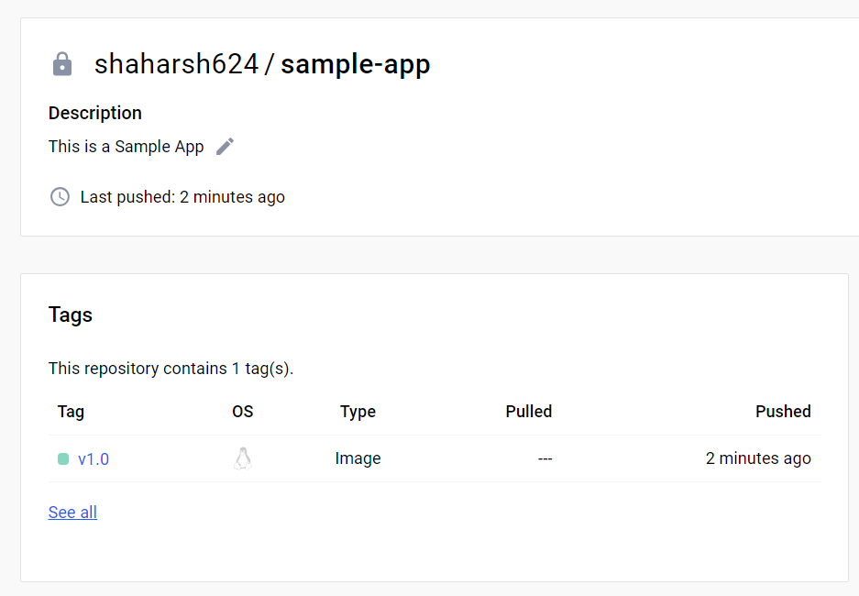

1. **Clean Up**

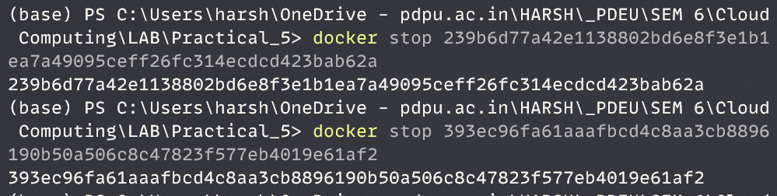

**PRACTICAL 5**

**Working with DOCKER**

**Aim:** Create two dockers with front-end and back-end applications and connect these containers. The details of the containers are given below:

**Web Application - Front-End + Back-End Application**

* MariaDB - Back-End (one container)
* WordPress - Front-End (different container)

1. **Execute MariaDB Container First**:

* Make the Container name Static like – some-mariadb
* Set the DB Root password using Env Variable - MARIADB_ROOT_PASSWORD
* Set the DB Username using Env Variable - MARIADB_USER
* Set the DB password using Env Variable - MARIADB_PASSWORD
* Set the DB Name using Env Variable - MARIADB_DATABASE

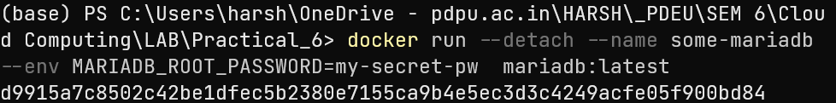

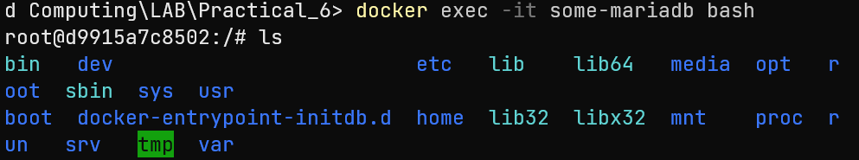

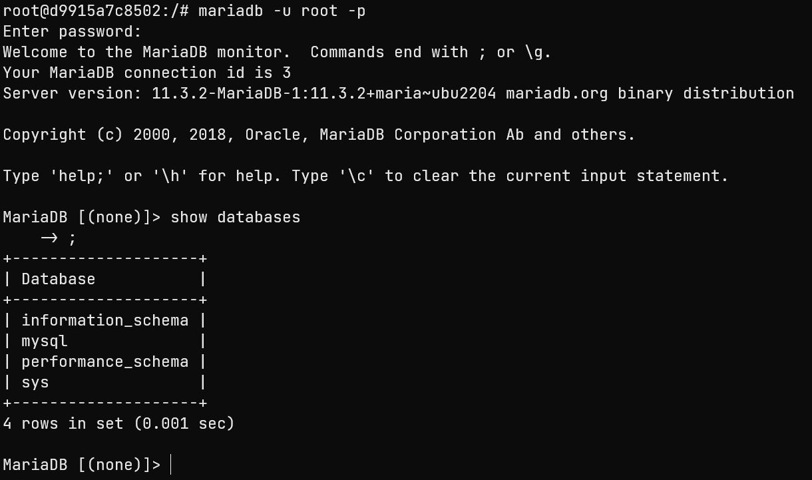

1. **Create a network**



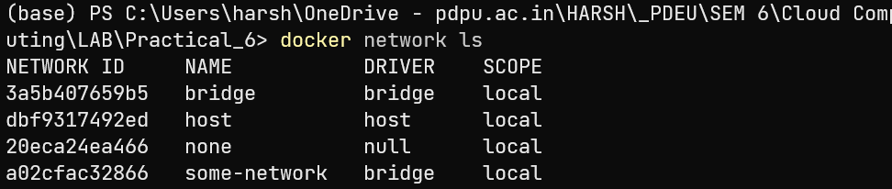

1. **Execute WordPress Container -**

* Make the Container name Static like - wordpress-container
* Set the DB Container Name in Env Variable - WORDPRESS_DB_HOST
* Set the DB Name in Env Variable - WORDPRESS_DB_NAME
* Set the DB User in Env Variable - WORDPRESS_DB_USER
* Set the DB password in Env Variable - WORDPRESS_DB_PASSWORD
* Expose Front-End Container on port 8080/80

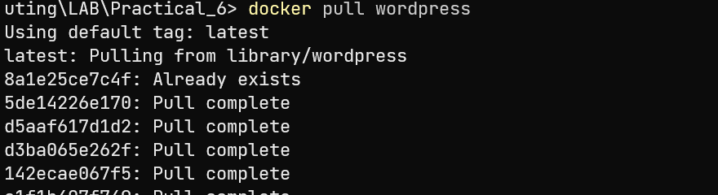

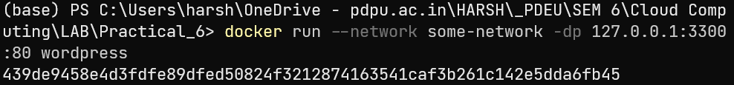

* Complete WordPress setup

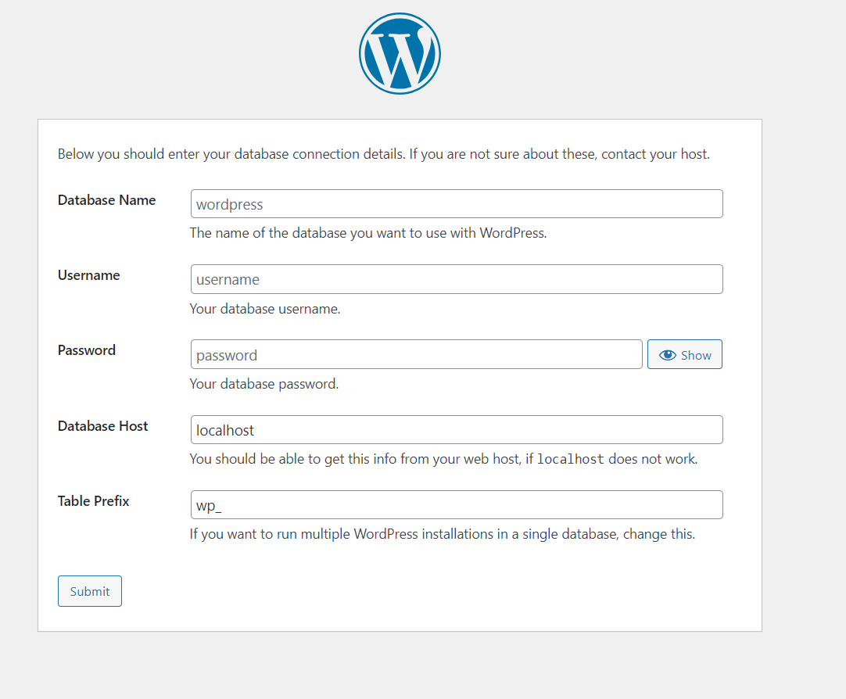



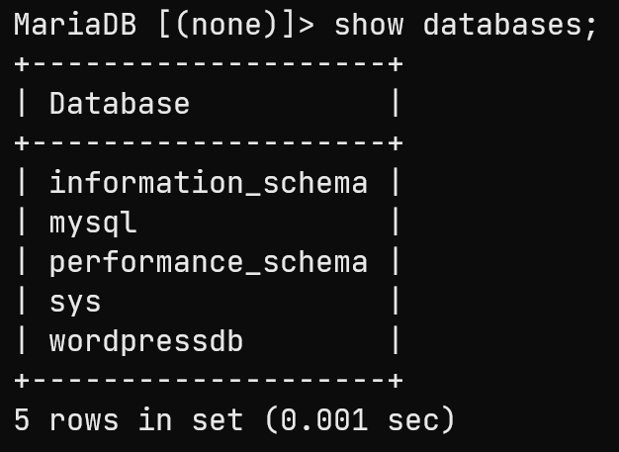

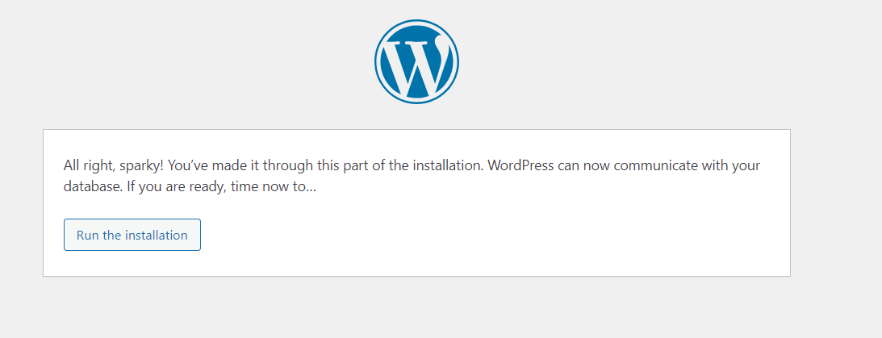

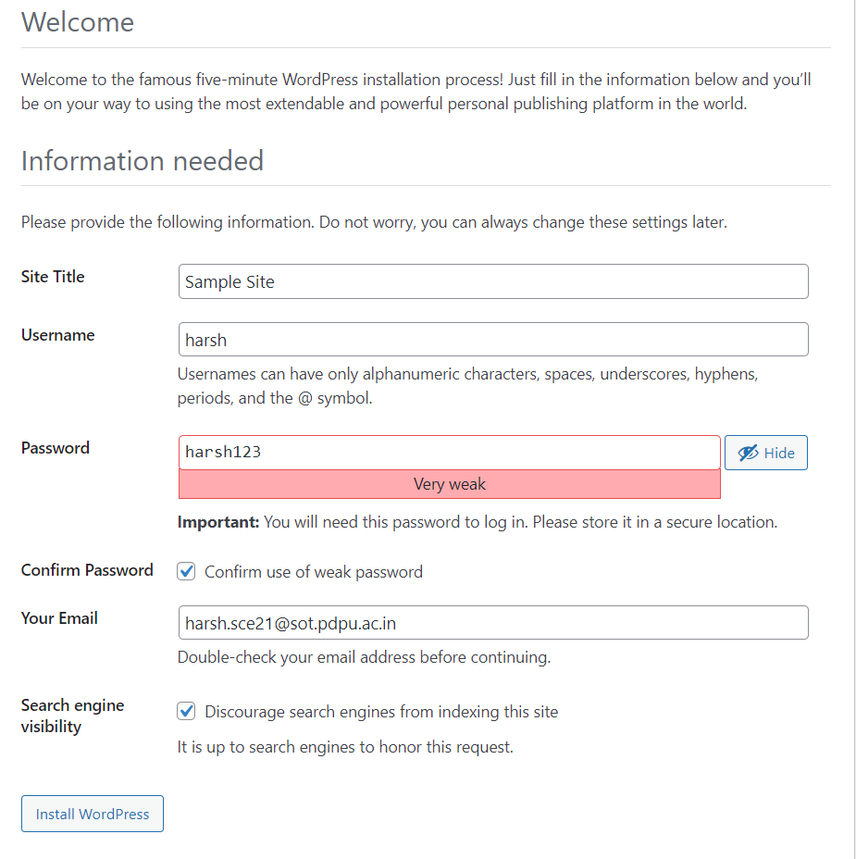

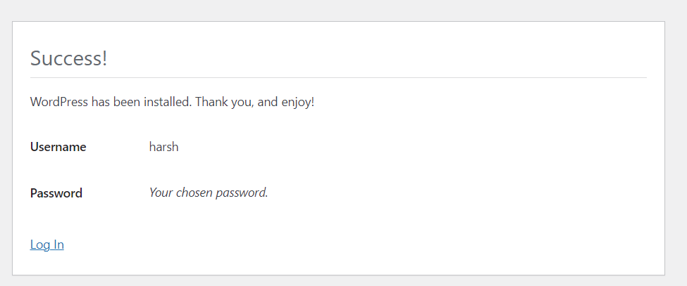

1. **Access Website on HostIP:PORT**

http://127.0.0.1:3300/

**PRACTICAL 6**

**Working with DOCKER**

**Aim:** Create a customized docker image and perform the following

1. **Create Docker File by own.**

ARG PYTHON_VERSION=3.11.7

FROM python:${PYTHON_VERSION}-slim as base

ENV PYTHONDONTWRITEBYTECODE=1

ENV PYTHONUNBUFFERED=1

WORKDIR /app

ARG UID=10001

RUN adduser \

    --disabled-password \

    --gecos "" \

    --home "/nonexistent" \

    --shell "/sbin/nologin" \

    --no-create-home \

    --uid "${UID}" \

    appuser

RUN --mount=type=cache,target=/root/.cache/pip \

    --mount=type=bind,source=requirements.txt,target=requirements.txt \

    python -m pip install -r requirements.txt

USER appuser

COPY . .

EXPOSE 8000

CMD python app.py

1. **Get the latest python image from Docker Repository.**

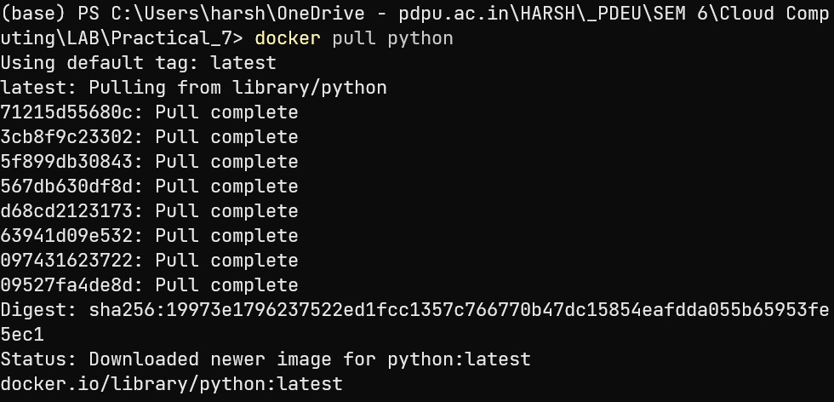

1. **Write down a simple python program or get it from internet.**

def fibonacci(*n*):

    a, b = 0, 1

    for _ in range(n):

        print(a, *end*=" ")

        a, b = b, a + b

fibonacci(10)

1. **Run Python Program inside the Container.**

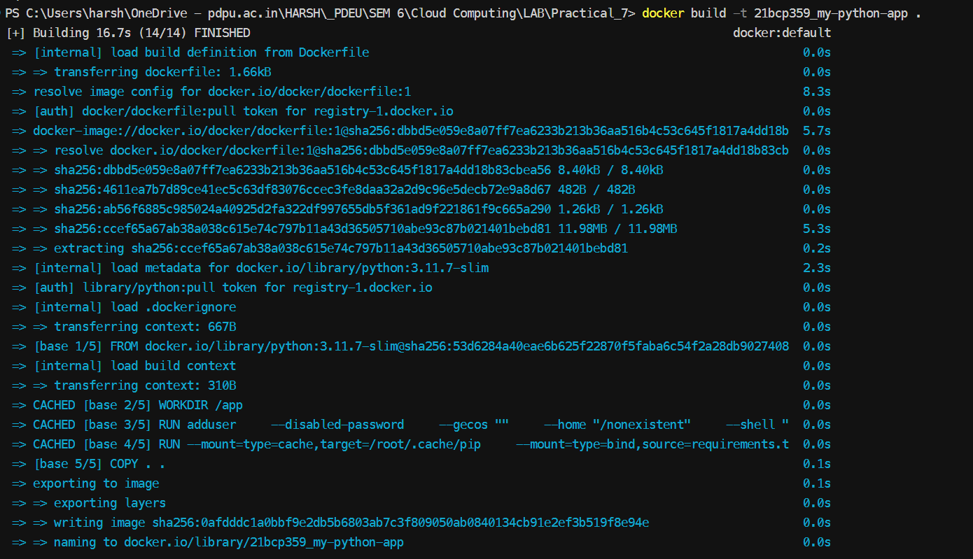



1. **Tag and Push the Image to Docker Hub.**

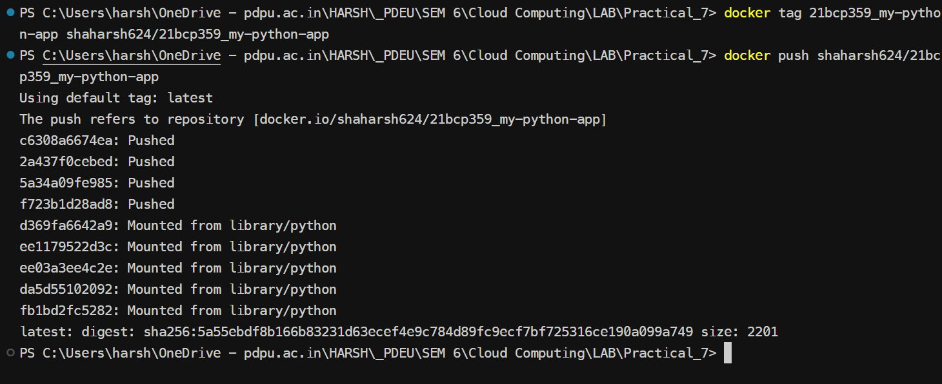

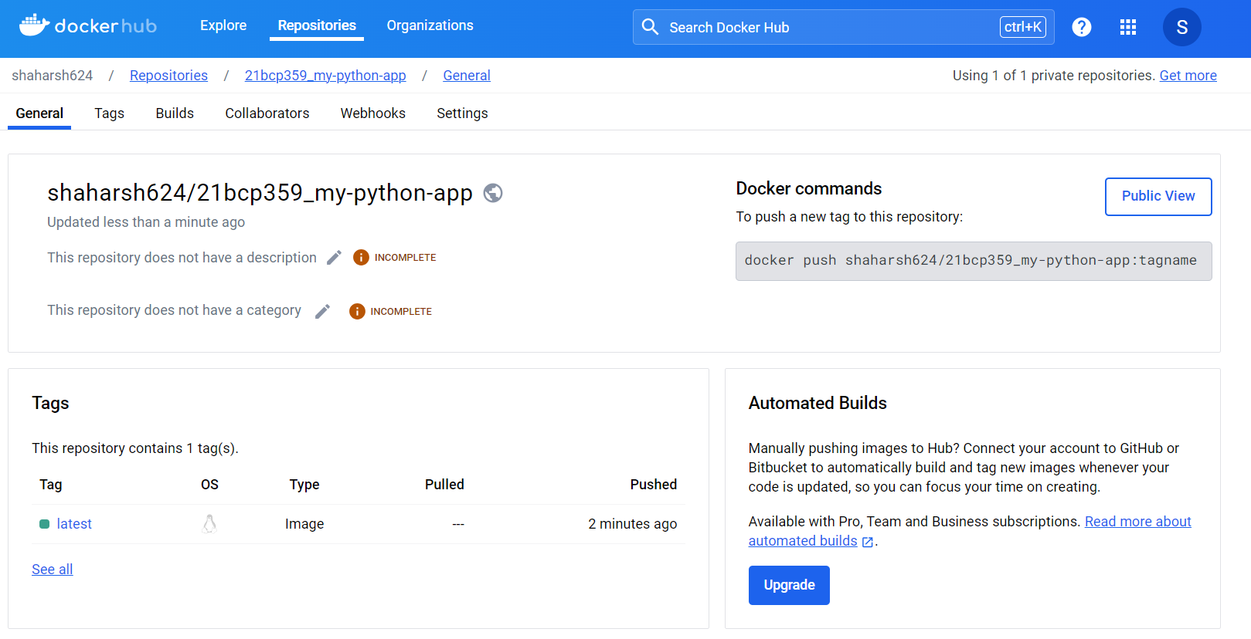

1. **Remove Image from Local and Again execute it from Hub.**

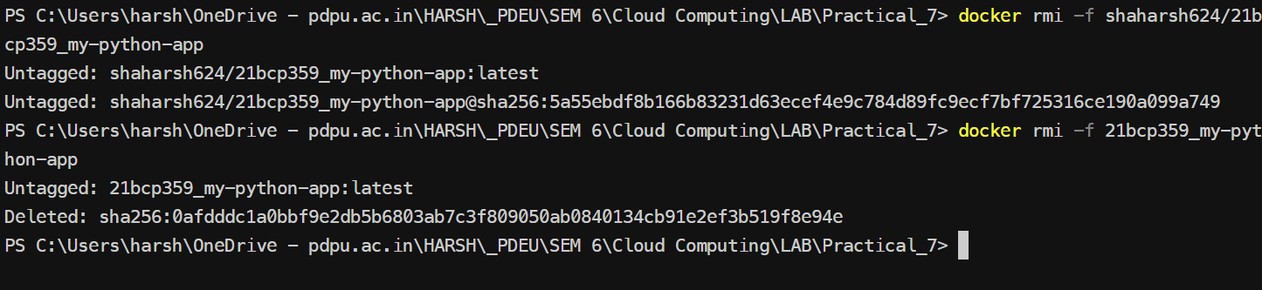

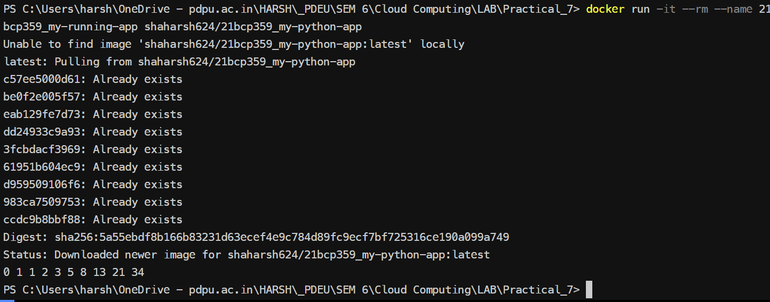

**PRACTICAL 7**

**Working with DOCKER**

**Aim:** Create three containers and access these containers from each other by using IP address and container name.

1. **Create three containers.**

Pull *busybox* Image

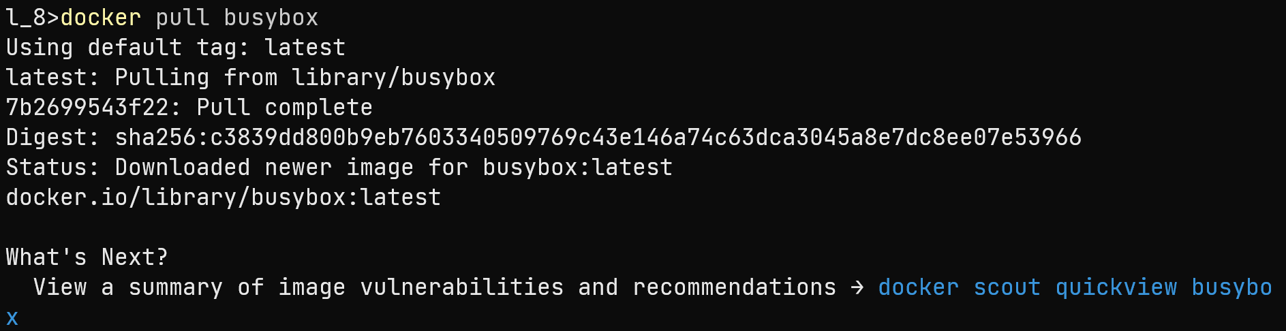

Create and run three containers

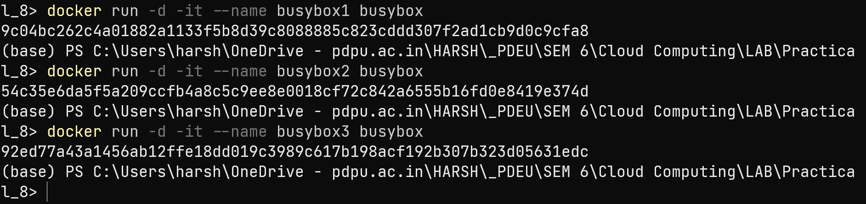

Create a network and connect with the containers



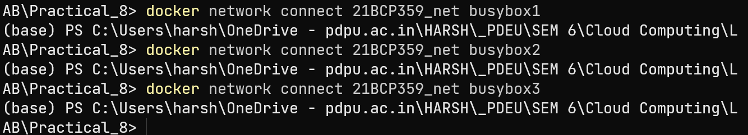

1. **Access these containers using IP address**

Find IP Address of containers







Ping from one container to another

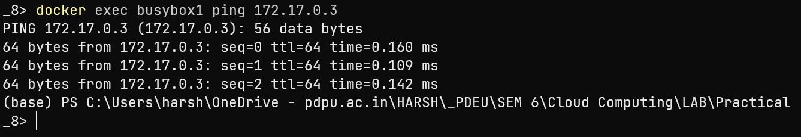

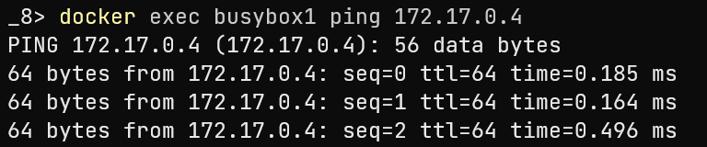

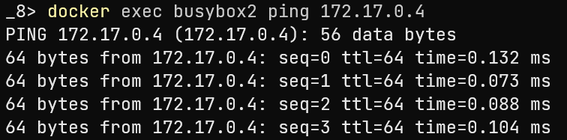

1. **Access these containers using container name.**

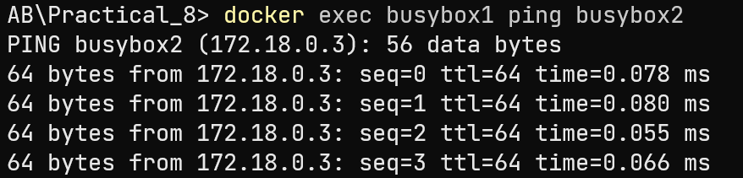

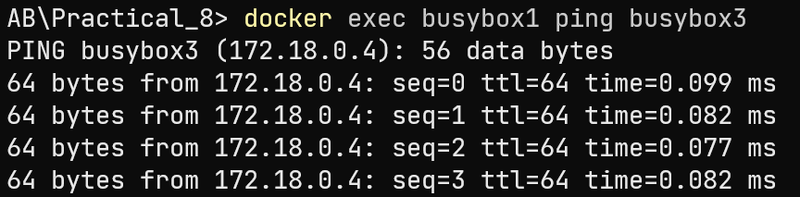

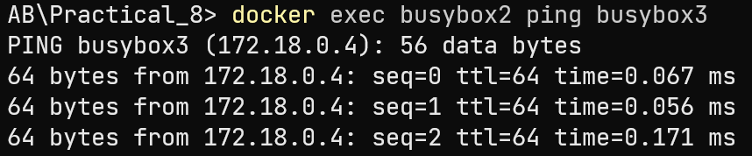

**PRACTICAL 8**

**Working with DOCKER**

**Aim:** Re-Do the problem of Lab 5 using docker compose. Also do assign a static IP address to WordPress container using subnetting.

Create two docker containers with front-end and back-end applications and connect these containers using docker compose.

1. **Running WordPress container normally**

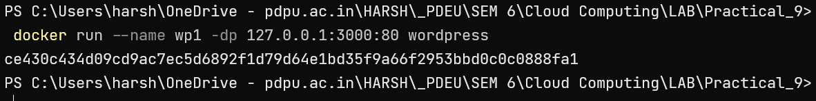

1. **Creating *compose.yaml* file**

services:

website1:

image: wordpress

ports:

- "3000:80"

1. **Execute Docker Compose**

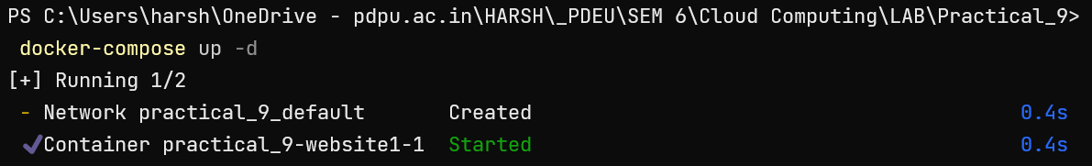

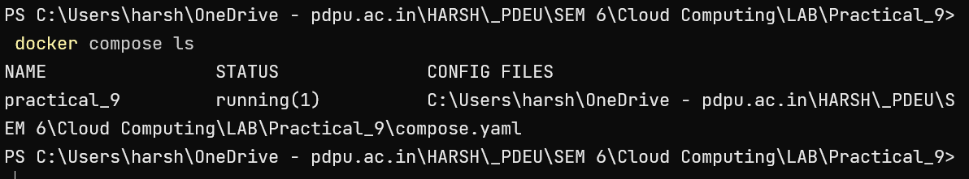

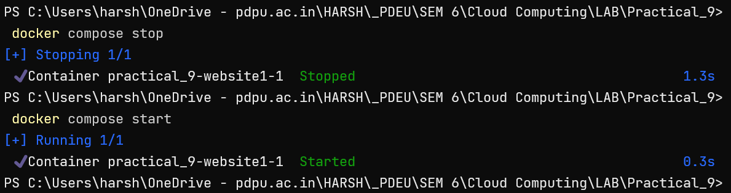

1. **Running multiple containers**

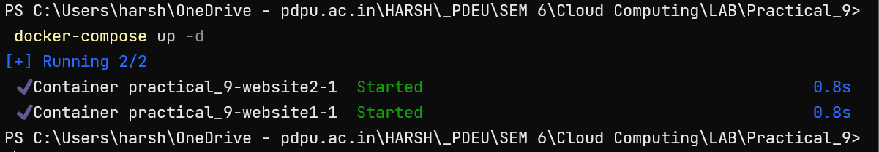

1. **Configuring network**

services:

  website1:

    image: wordpress

    ports:

      - "3100:80"

  website2:

    image: wordpress

    ports:

      - "3200:80"

networks:

      wordpress_net:

        ipv4_address: 192.168.99.20

networks:

  wordpress_net:

    ipam:

      driver: default

      config:

        - subnet: "192.168.99.0/24"

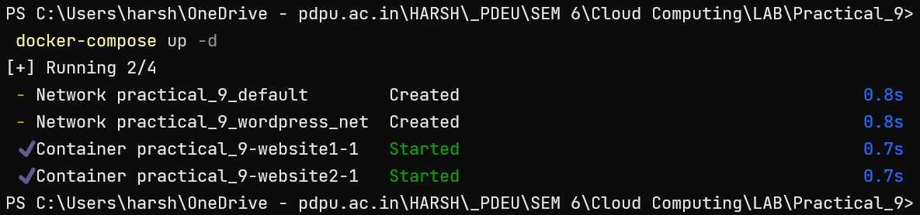

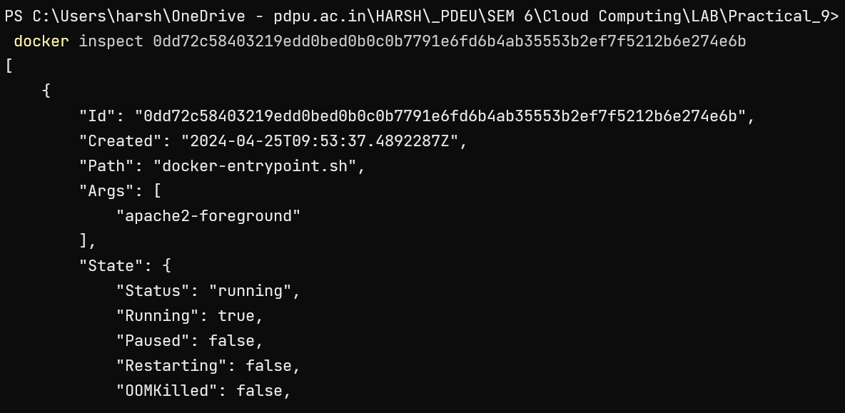

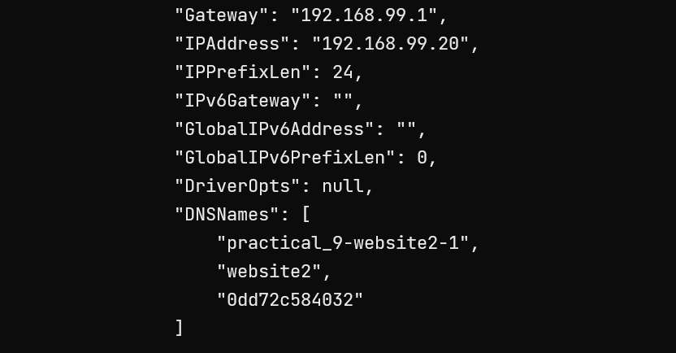

1. **Connection Database with Container**

version: "3"

services:

  mariadb_db:

    container_name: mariadb_container

    image: mariadb

    restart: always

    environment:

      MARIADB_ROOT_PASSWORD: password

      MARIADB_DATABASE: testdb

      MARIADB_USER: harsh

      MARIADB_PASSWORD: wp_password

    volumes:

    - mariadb_vol:/var/lib/mysql

  wordpress:

    depends_on:

      - mariadb_db

    image: wordpress:latest

    restart: always

    ports:

      - "8000:80"

    environment:

      WORDPRESS_DB_HOST: mariadb_db:3306

      WORDPRESS_DB_NAME: testdb

      WORDPRESS_DB_USER: harsh

      WORDPRESS_DB_PASSWORD: wp_password

    volumes:

      ["./:/var/www/html"]

volumes:

 mariadb_vol: {}

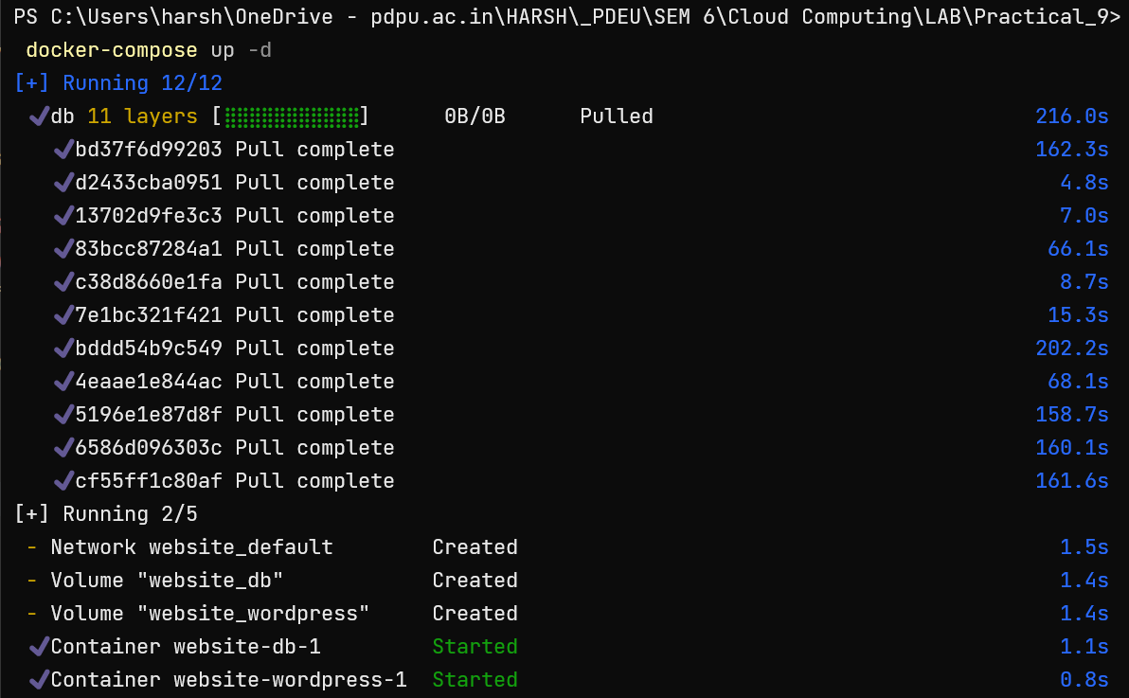









1. **Access Website on HostIP:PORT**

<http://127.0.0.1:3300/>